DATA VISUALIZATION AND DATA PROFILE IN DATABRICKS

To visualize the data, we'll begin by obtaining a CSV file from any website. Then, we'll log in to DataBricks, upload the CSV file into a table, and retrieve its path. Finally, we'll write code to perform data visualization using the retrieved path.

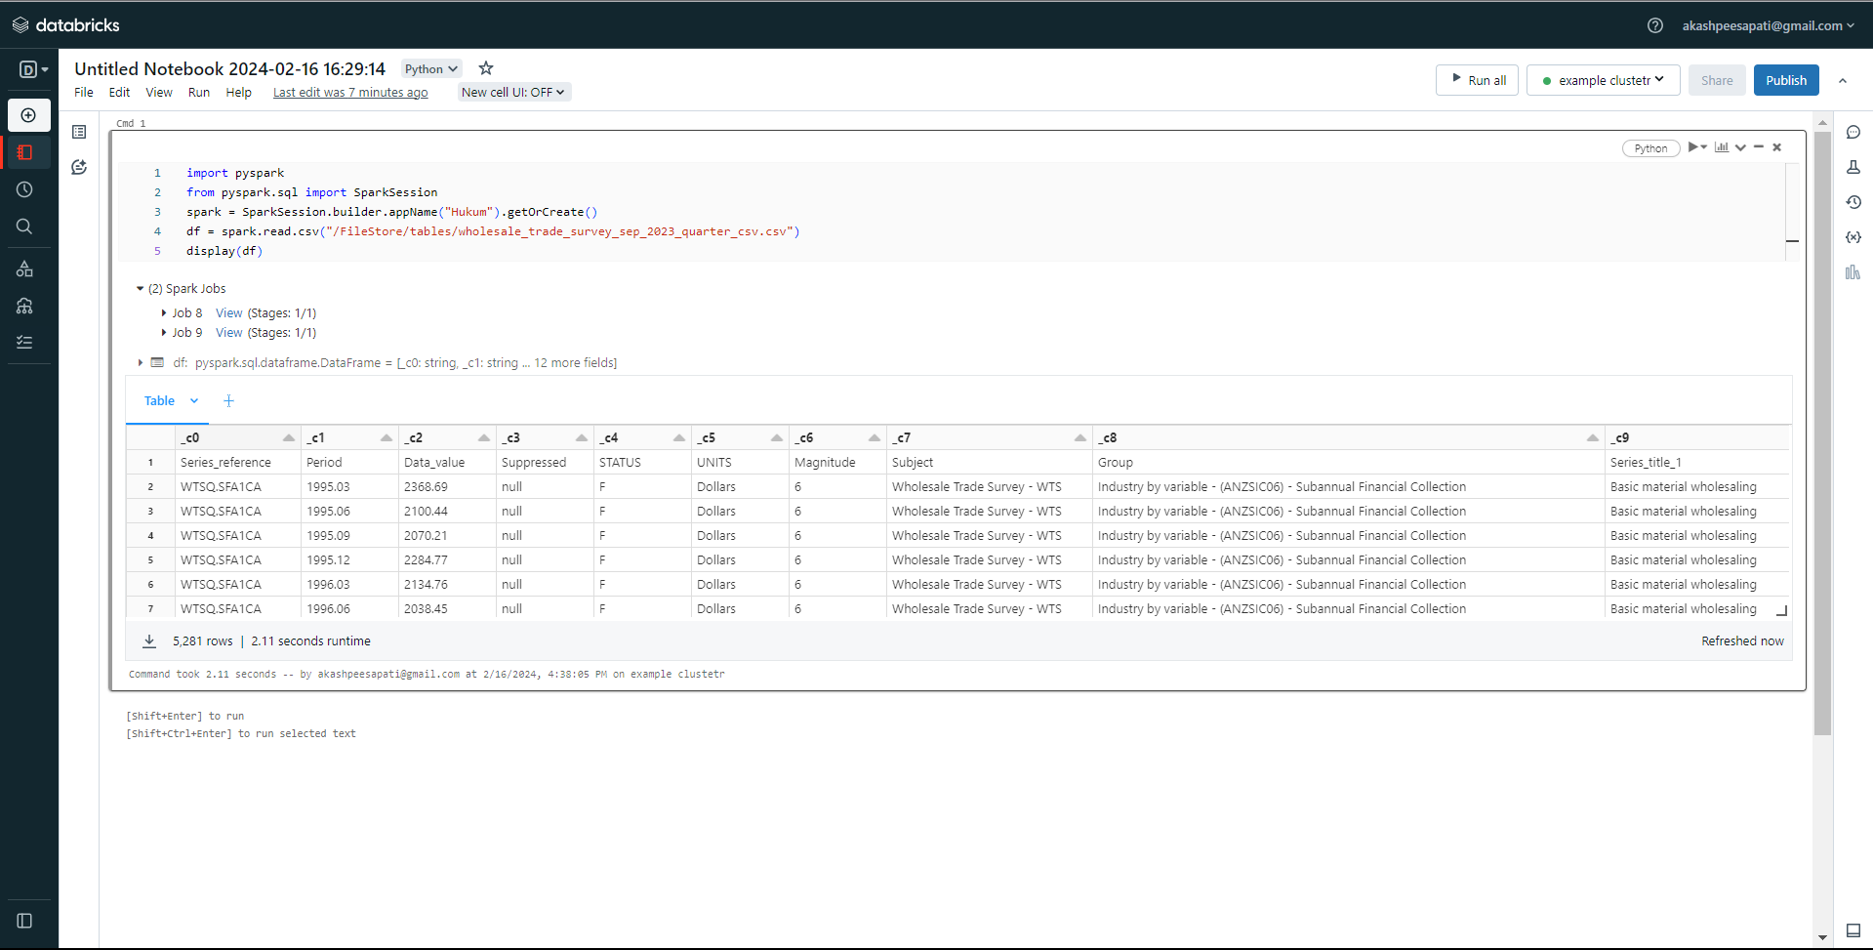

Once you've run the code, you'll see the resulting table displayed. From there, click on the plus sign (+) and choose "Visualization." Next, select the type of visualization you prefer and designate the 'X' and 'Y' columns. Additionally, you have the option to select a "Group by" parameter if needed. After customizing your visualization, save it for future reference. The image below illustrates the data visualization process.

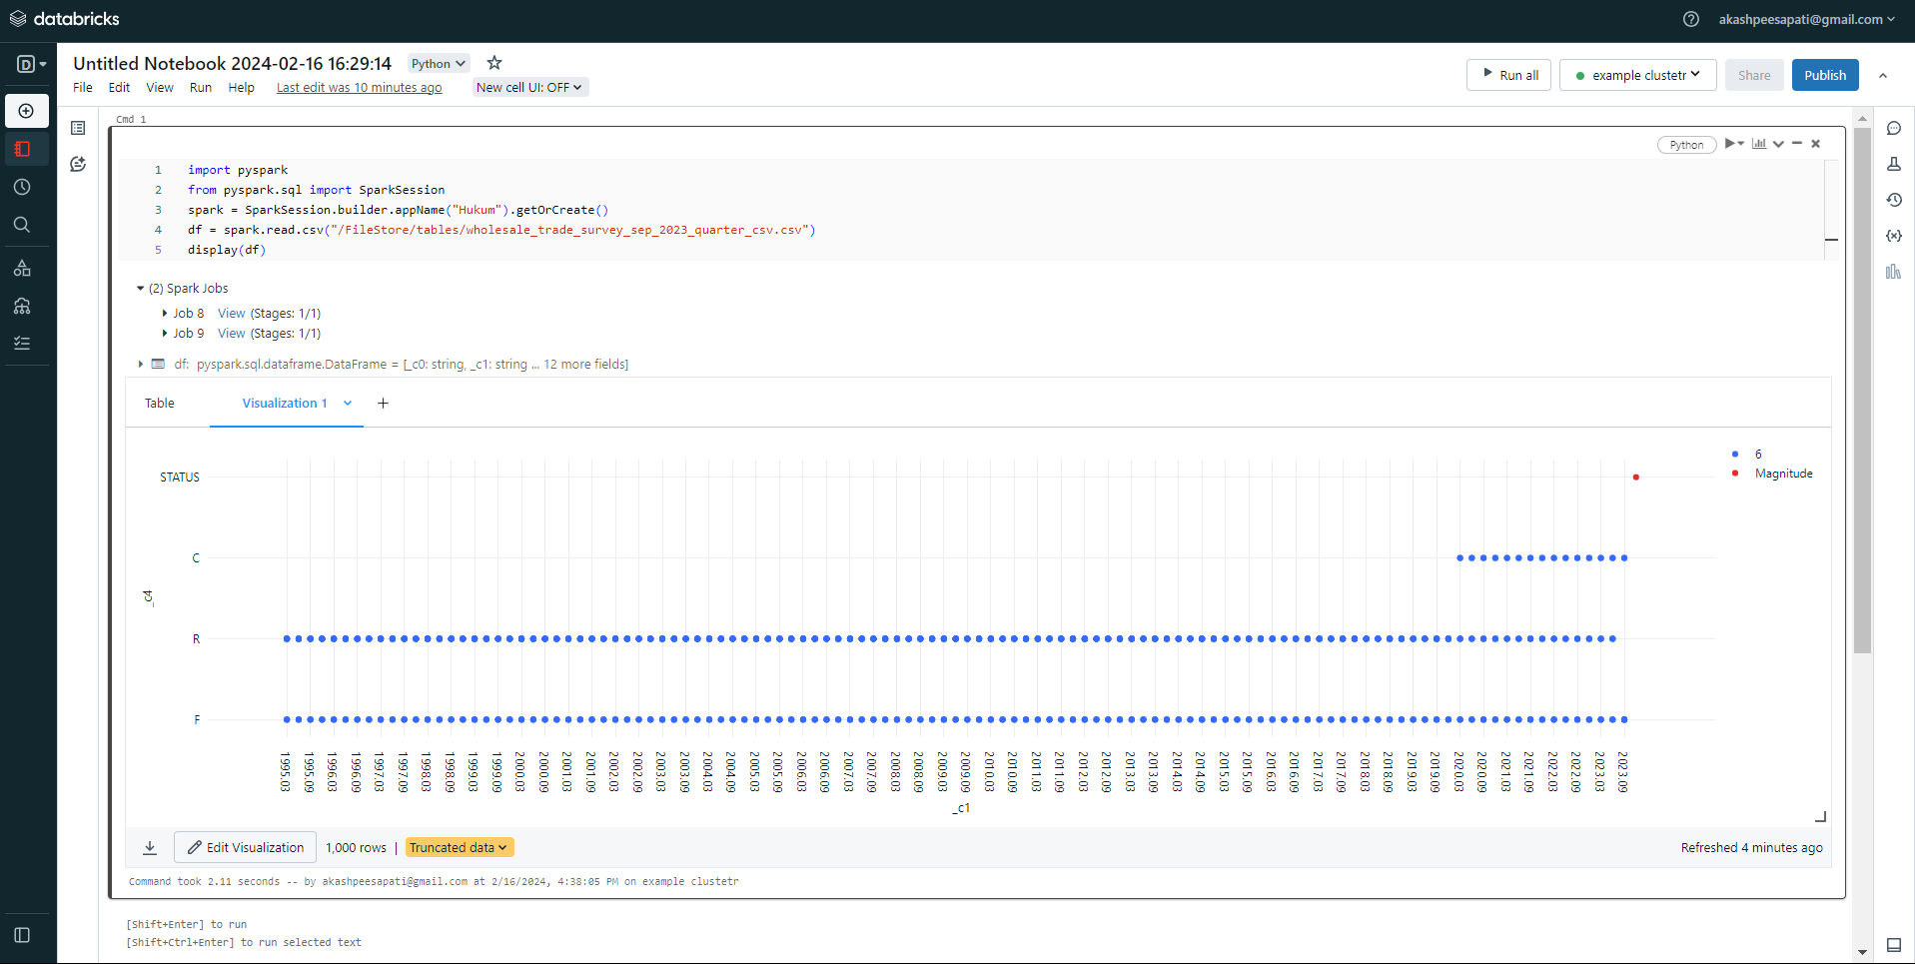

Also, we can observe Data Profile and the image is shown below:

